[](http://www.google.co.uk/url?sa=i&rct=j&q=&esrc=s&source=images&cd=&cad=rja&uact=8&ved=0CAcQjRw&url=http://www.mycutegraphics.com/graphics/reading/girl-reading-book.html&ei=S59rVO2jEZS1yATw14LYDA&bvm=bv.79908130,d.cWc&psig=AFQjCNHwzqT8eav9Iz7PjC-tOPBm6hHFSQ&ust=1416425628887476)

**English –**We will be reading Short and Spooky stories as our class book in English and developing our skills of comprehension. We will learn what a fronted adverbial is and then use them in our writing. We will practise our handwriting, learning joins and ensuring letter formation is correct. Spellings will stuck in their Homework books on a Friday and tested the following Friday.

**Maths** – We will be looking at the value of digits and how to represent them in different ways. We will be ordering, comparing and rounding numbers. Year 4 will also be working with negative numbers and Roman numerals. We will then move onto addition and subtraction using a variety of methods and equipment. The children will also learn column addition and subtraction. We will continue to learn our times tables through Rock Star Tables. We will revise our x2, x5 and x10. Year 3 will then look at x3 whilst Year 4 learn x6. With all aspects of maths, applying it to real life situations is important. At home, please help your child with understanding time and recognising simple times such as o’clock, half past, quarter past and quarter to.

**PE -** NUFC sessions

**PE –** Ball Skills: throwing, catching, aim and accuracy

**RE –** We will find out how and why people try and make the world a better place. We will reflect upon our school ethos and what it means to be a part of our church community.

**French–** We will learn French vocabulary to help us read Little Red Riding Hood.

**Music-** We will listen to different genres of music and discuss our likes and dislikes. The Charanga music unit is Writing Music Down so we will learn about notation and have a go at composing our own music.

**PSHE–** Commando Joe’s will focus on team building tasks and communication.

**History : Stone Age to Iron Age-** We will find out about how people lived in the Stone age; what their houses looked like and how they survived by hunting and living off the land. We will compare early Stone Age living to Bronze and Iron Age living and note the changes in daily life.

**Science-** We will be finding out about Animals Including Humans. We will learn to label a skeleton, find out about how our muscles work and how a balanced diet keeps our bodies and minds active and healthy.

**ICT-** Online Safety & Spreadsheets

Autumn 1

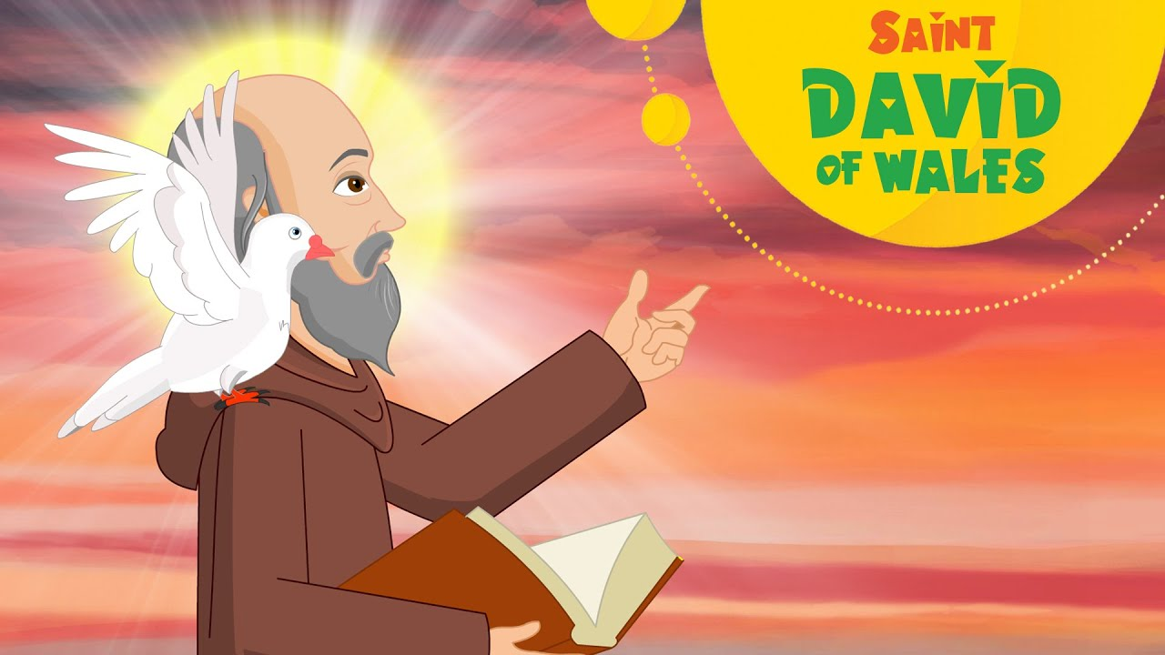

**Art**- We will use different media to create images of Stone Henge. We will develop our fine motor skills to use pastel, pencil, pens, paint and also practise cutting out accurately.